Topic 3: DEDUCTIVE PROOF
The basis for mathematical constructions and deductions remains the shapes themselves, be it plane or solid. As a result, we are tasked with a greater need to inspect the core characteristics of the shapes in question.
Objectives:
At the end of the session, the student will be able to:
- Prove that the sum of angles of a triangle is 180 degrees.
- Prove the relationship between exterior and interior angles of a triangle.
- Explain congruent triangles and angles between parallel lines.
- Explain the properties of the intercept theorem.
- ANGLES ON LINES
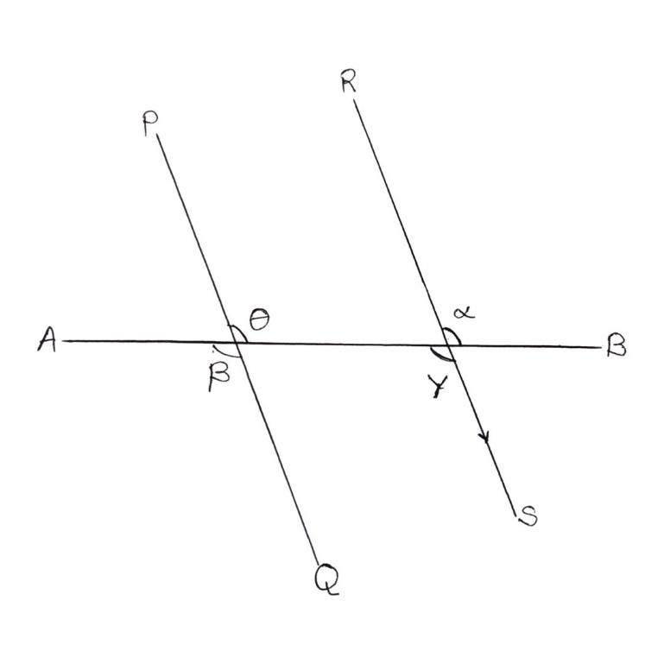

- CORRESPONDING ANGLES
These are angles which occupy the same relative position at each intersection where a straight line crosses each other. If the two lines (in this case, PQ and RS) are parallel, then the corresponding angles are equal.
$$θ=α ; β=γ$$
- OPPOSITE ANGLES
These are non-adjacent angles formed by two intersecting lines.
$$θ=β ; α=γ$$
- ALTERNATE ANGLES
These are two angles formed when a line (in this case, AB) crosses two other lines that lie on opposite sides of the transversal line and on opposite relative sides of the other lines. When the two other lines are parallel (in this case, PQ and RS), the alternate angles are equal.
$$θ=γ ; α= β$$
- TOTAL ANGLES IN A TRIANGLE
Consider a triangle ABC with angles $θ, α and β$ at A, B and C respectively.
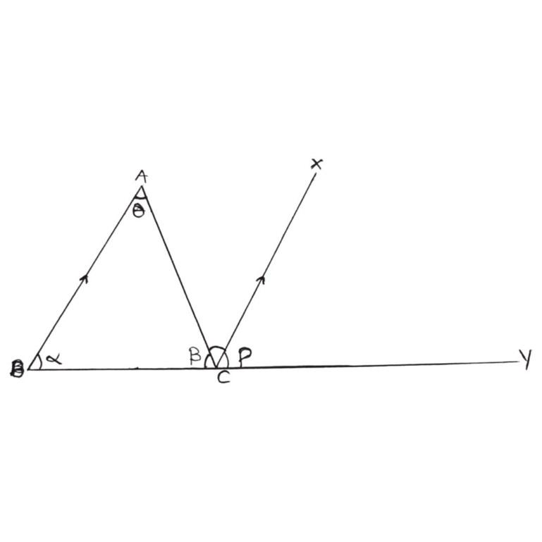

Extend the line at C to a point Y, and draw XC parallel to AB,
Clearly,
$$θ=γ (alternate angles)$$
$$α= ρ \left(corresponding angles\right)$$
$$β+γ+ρ=180° \left(angle on a straight line\right)$$
So,
$$β+θ+α=180°$$
Thus, the total sum of angles in a triangle is $180°$
RELATIONSHIP BETWEEN EXTERIOR AND INTERIOR ANGLES IN A TRIANGLE.
- The exterior angle of a triangle is equal to the sum of the opposite interior angles.
Consider a triangle ABC, with the line BC extended at C to a point Y. let the angles at A,B and C be $θ, α and β respectively.$
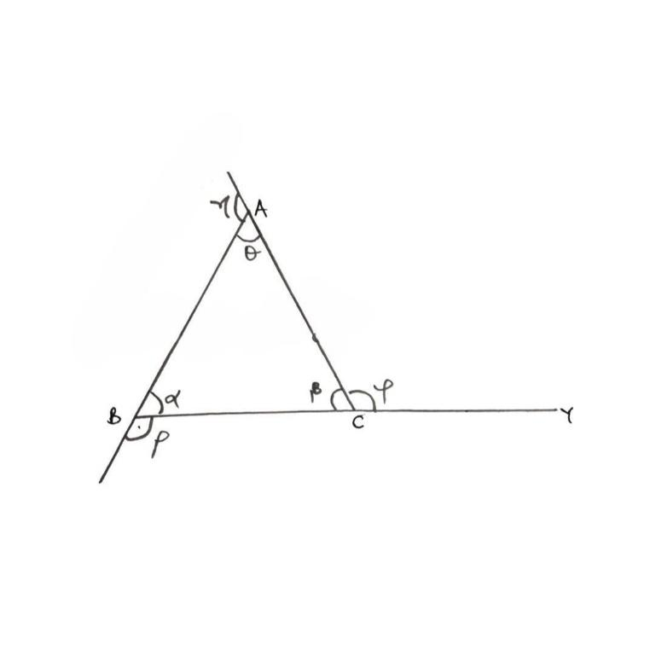

Clearly,
$$β+γ=180° \left(angle on a straight line\right)$$
$$θ+ α+ β=180° \left(angle in a triangle\right)$$
Thus, $β+γ= θ+ α+ β$
$θ+ α= γ$
Hence, the sum of the opposite interior angles ( $θ and α)$ equals the exterior angle ($γ) of a triangle.$
CONGRUENT TRIANGLES
Two triangles are said to be congruent if they have both the same shape and the same size. i.e. The value of their sides is the same; as well as the value of their angles are also the same.
There are five major ways to verify congruence.
- SSS - Side, Side, Side: this means that all the side values are given for the triangles.
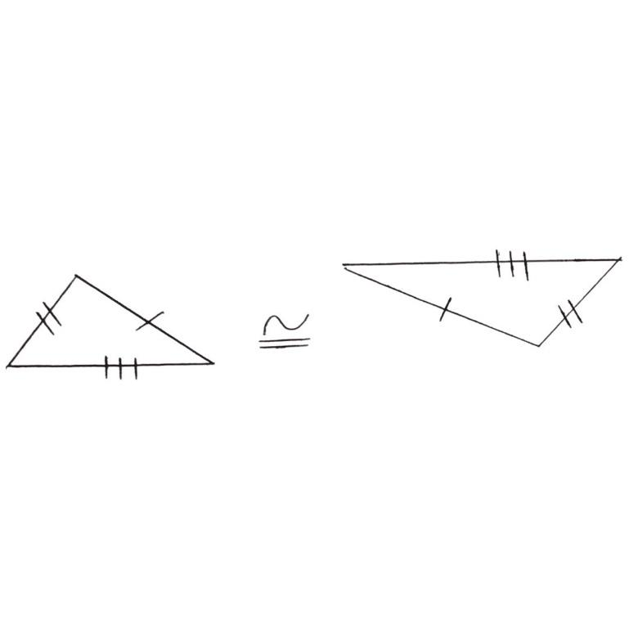

- SAS – Side, Angle, Side: Here, two of slides are known, with one angle opposite the unknown side.
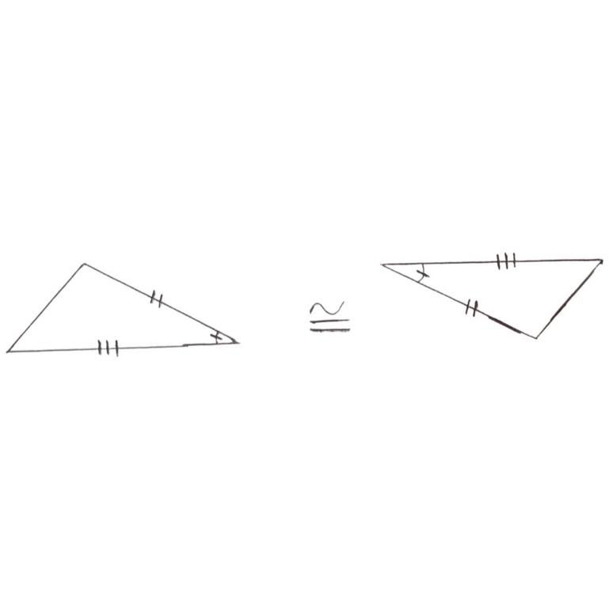

- ASA – Angle, Side, Angle: Here, two angles are known and the side opposite the unknown angle.
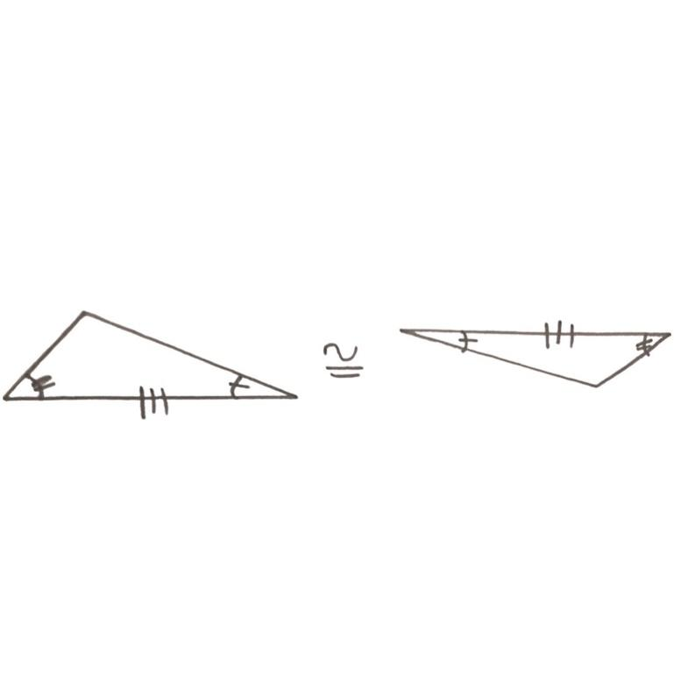

- AAS – Angle, Angle, Side: Here, two angles are known, plus a side that is NOT in between the known angles.
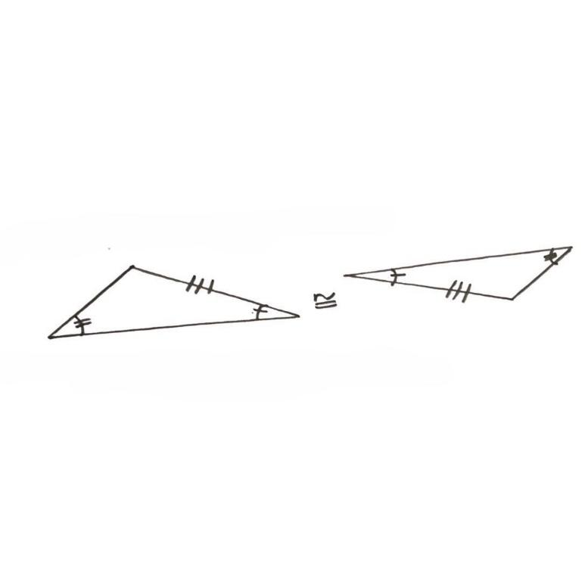

- HL – Hypothenuse, Leg: This applies to only right-angled triangles. Here, the hypothenuse is wrong, as well on of the other two sides.
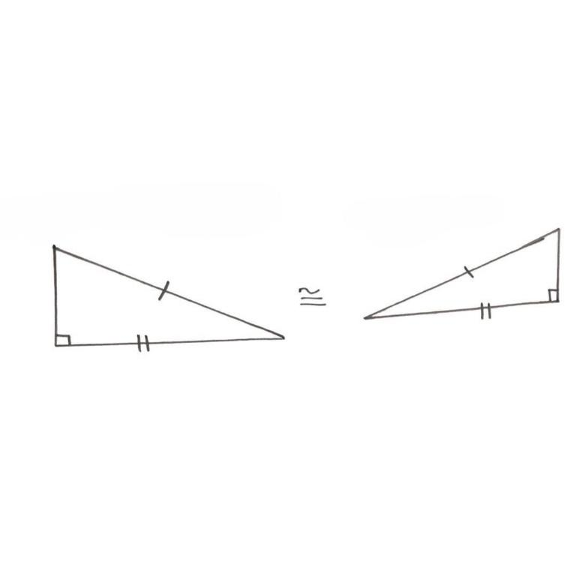

SHAPE ANALOGY
- POLYGON
Polygons are closed sided plane shapes or figures. In other words, they have at least three straight sides and three angles. Examples are triangles, squares, rectangles, pentagons, etc.
- REGULAR POLYGONS
These are polygons where all its sides are equal and all its interior angles are equal. Examples are equilateral triangles, squares, regular pentagons, regular hexagons, etc.
TRIVIA: Not all triangles are regular polygons. In fact, only the equilateral triangle is a regular polygon.
- CONVEX POLYGONS
These are polygons where all their interior angles are lesser than $180°.$ All regular polygons are convex.
- SIMPLE POLYGON
These are polygons that do not have self-intersecting sides. All regular polygons are simple.
- The sum of the exterior angles of any convex polygon is 4 right-angles.
` Consider a triangle ABC, with angle $θ,α and β at A,B and C respectively and the line BC extended at C to apoint γ$and the exterior angles at A,B and C as $γ,ρ and φ respectively.$


Clearly,
$θ+α=φ \left(exterior angle is equal to the sum of the opposite interior angles \right)$
$α+ β=γ$
$θ+ β=ρ$
We have to show that
$γ+ φ+ ρ=360°$
$$consider L.H.S$$
$γ+ φ+ ρ= α+β+θ+α+θ+β$
= ($α+β+θ)+(α+β+θ)$
Since $α+β+θ=180° \left(total angles in triangle\right)$
Then,
$γ+ φ+ ρ=180°+180°=360°=R.H.S$
This holds true for any and every single convex polygon (which includes regulars polygons as well).
- The sum of interior angles of any convex polygon is (2n – 4) right- angles.
Consider a 5-sided polygon (pentagon) A,B,C,D,E.
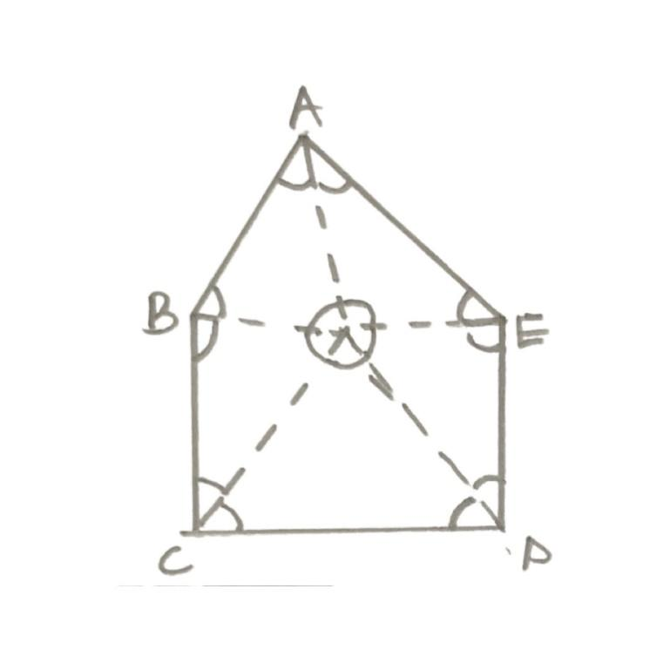

Splitting into 5 triangles, from a common point, we have that
Total angles in 5 triangles = 180 $×5=900$
Thus, Total Angles in n triangles = 180n
Total angle at the common point = 360$°$
The angles at the A,B,C,D and E are the interior angles.
So,
Total sum of interior angles = $\hat{A}$ + $\hat{B}$+ $\hat{C}$ + $\hat{D}$ + $\hat{E}$
Hence,
Sum of interior angles + angle at common point = Total angles in n Triangles
Sum of interior angles + 360$°=180n$
So, sum of interior angles = 180n – 360
= 90 (2n – 4)
= (2n – 4) right- angles
For the pentagon,
Sum of interior angles = 180 (5) – 360
= 900 – 360
= 540$°$
TRIVIA
For regular polygons, where the interior angles and the sides are equal, we can find the value of the interior angle by simply dividing the total sum of interior angles by the number of sides.
i.e. Interior Angle of a regular n-sided polygon = $\frac{180n-360}{n}$
INTERCEPT THEOREM
This is also known as the “Thales’ Intercept Theorem.
The theorem blankly states that the segments created by parallel lines are proportional. The intercept theorem provides the ratios between the line segments created when two parallel lines are intercepted by two intersecting lines.
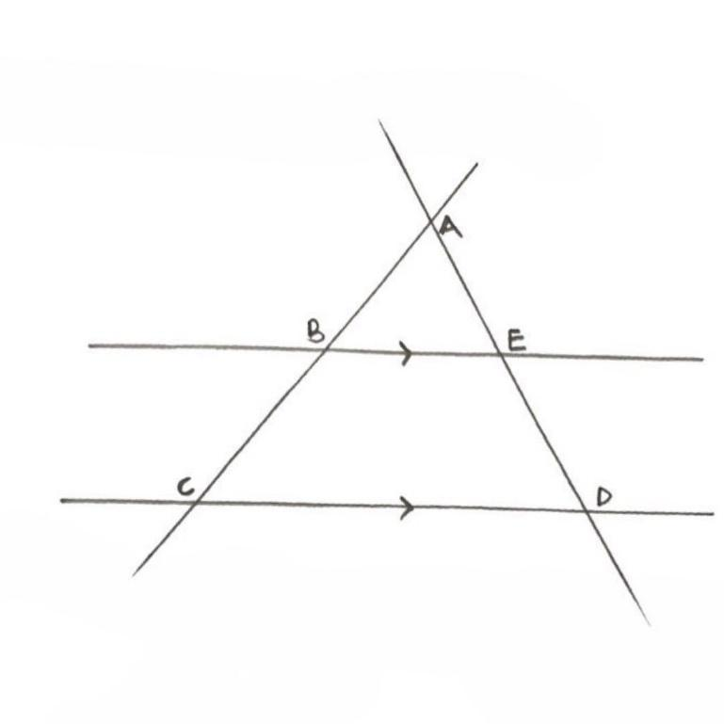

Thus,
$$\frac{AB}{AC}=\frac{AE}{AD}=\frac{BE}{CD} and \frac{AB}{BC}=\frac{AE}{ED}$$
Example
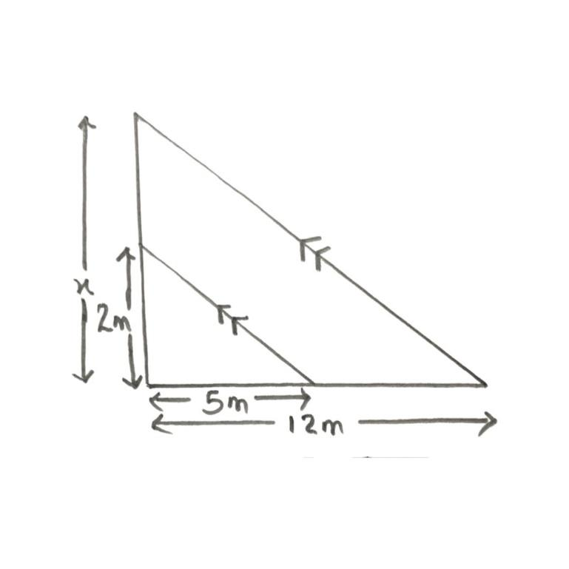

By Thales’ intercept theorem,
$$\frac{2}{x}=\frac{5}{12}$$
5x=24
X= 4.8m

